**Ideation Phase**

**Define the Problem Statements**

|  |  |
| --- | --- |
| Date | 28 June 2025 |
| Team ID | LTVIP2025TMID48306 |
| Project Name | **Comprehensive Analysis and Dietary Strategies with Tableau: A College Food Choices Case Study** |
| Maximum Marks | 2 Marks |

**Customer Problem Statement Template:**

Create a problem statement to understand your customer's point of view. The Customer Problem Statement template helps you focus on what matters to create experiences people will love.A well-articulated customer problem statement allows you and your team to find the ideal solution for the challenges your customers face. Throughout the process, you’ll also be able to empathize with your customers, which helps you better understand how they perceive your product or service.

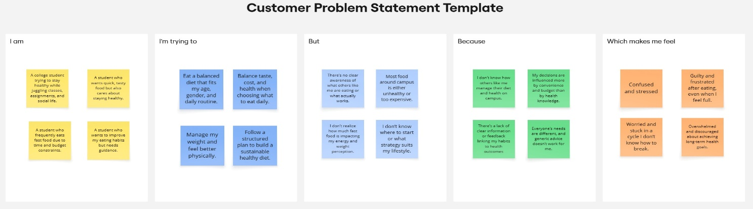

|  |  |  |  |  |  |
| --- | --- | --- | --- | --- | --- |
| **Problem Statement (PS)** | **I am (Customer)** | **I’m trying to** | **But** | **Because** | **Which makes me feel** |
| PS-1: Diet Awareness Gaps | A college student balancing academics and health | Eat a balanced diet that suits my routine | I don’t know how others like me manage their diet and health | There’s no clear visibility or shared info on peer habits | Confused and unsure if my choices are right |
| PS-2: Influenced by Convenience | A student who values taste and budget | Choose meals that are both tasty and healthy | Campus food is often unhealthy or costly | My choices are driven more by convenience than health | Guilty and frustrated after eating |
| PS-3: Fast Food Reliance | A busy student who eats fast food regularly | Manage my weight and feel better physically | I’m unsure how fast food affects my health | There’s a lack of feedback or awareness about the impact | Worried and stuck in a bad cycle |
| PS-4: Need for Personal Guidance | A motivated student wanting to improve diet. | Follow a healthy, personalized diet plan | I don’t know what plan suits my lifestyle | Generic advice doesn’t match my individual needs | Overwhelmed and discouraged |

